

**DEPARTMENT OF COMPUTER SCIENCE**

**FORMAN CHRISTIAN COLLEGE**

**(A Chartered University)**

**LAHORE, PAKISTAN**

**COMP-311 (B)**

**Computer Networks**

**Project**

**Bluetooth Controlled Car (with Arduino)**

**Members**

**Abdullah Mehtab || 241607845**

**Umm-e-Abiha || 231522019**

**Submitted to: Ma’am Asma Basharat**

**Materials Required:**

* Arduino Nano board HC-05 Bluetooth module

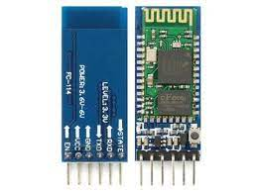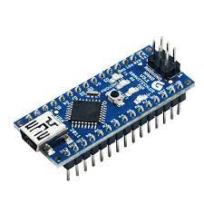

* L298N motor driver Gear motors (4)

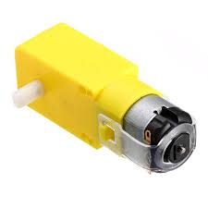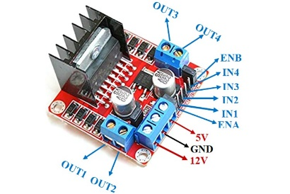

* Robot wheels (4) Chargeable Batteries

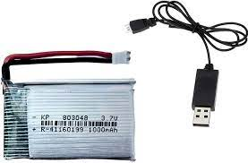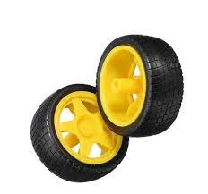

* Jumper wires (M-M, M-F, F-F) Breadboard

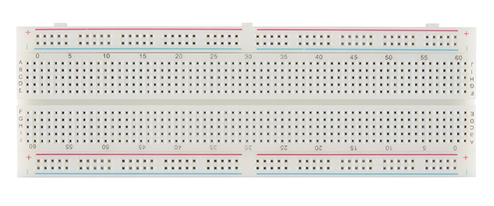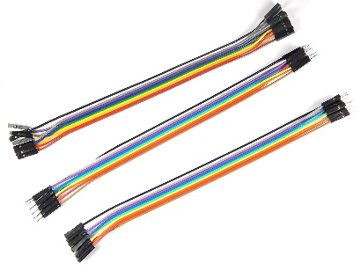

**Software Required:**

* Arduino IDE
* SriTu Hobby Mobile Software

**Introduction:**

This Report will be our experience of learning how to create a Bluetooth controlled Arduino Car, in a tutorial style, which will make it easy for anyone reading to understand, as well as show our working.

**Why make this?**

Two semesters ago, we were tasked with making a line following robot car, which is why we already had half the required components to make this project. That is why we bothered with it in the first place since these components are really weak, but expensive and would not want to do it as most of the time due to inexperience, the hardware ended up damaged with nothing working.

**Our experience of making it**

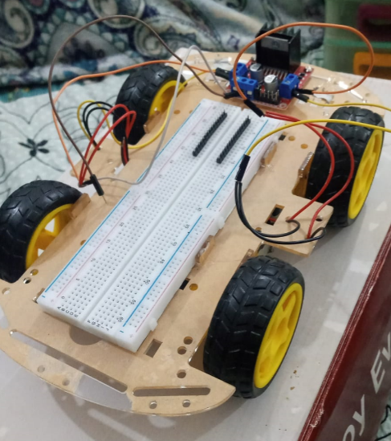 Since we had the body of the car from an older course. The main task was to do the Networking Part using the Bluetooth Module and Arduino Nano.

The Circuit Diagram to follow. In my case there are FOUR tires, so they will simply be connected aswell.

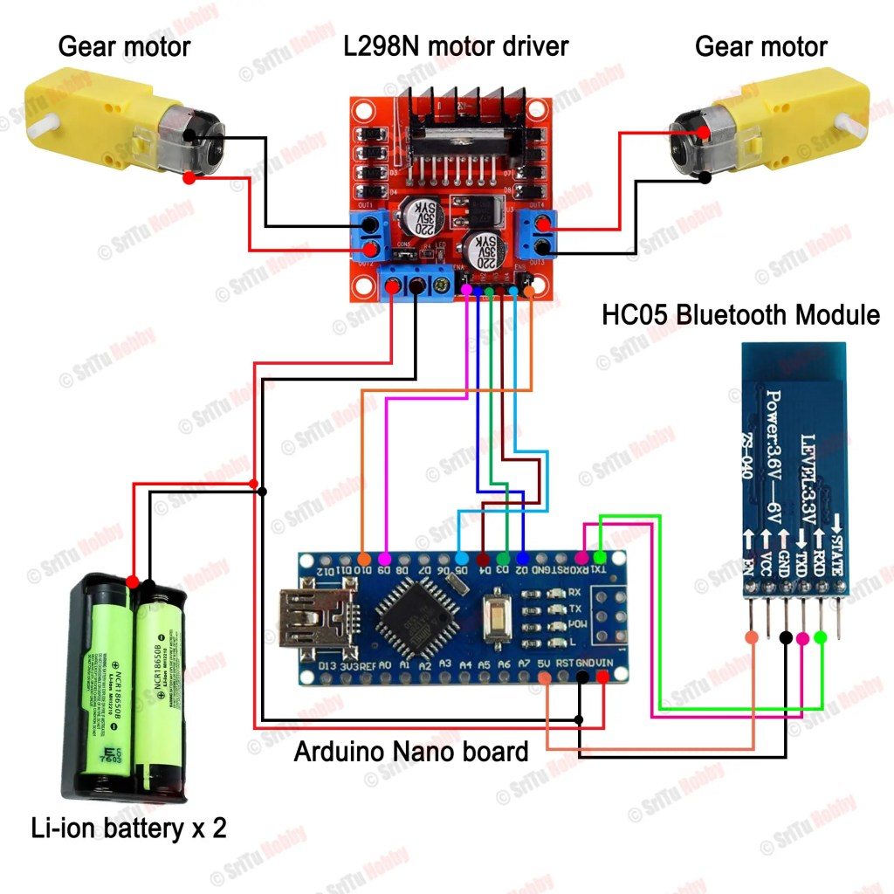

Some small things to Remember since electronics.

Ground is -ve || VCC/5v is +ve

TXD means Transmission || RXD means Receiving

The battery of the Car was already connected to the motor driver and the wheels due to the old project. Other than that

* Bluetooth Module and Arduino Nano is added
* the Rechargeable batteries are added in series

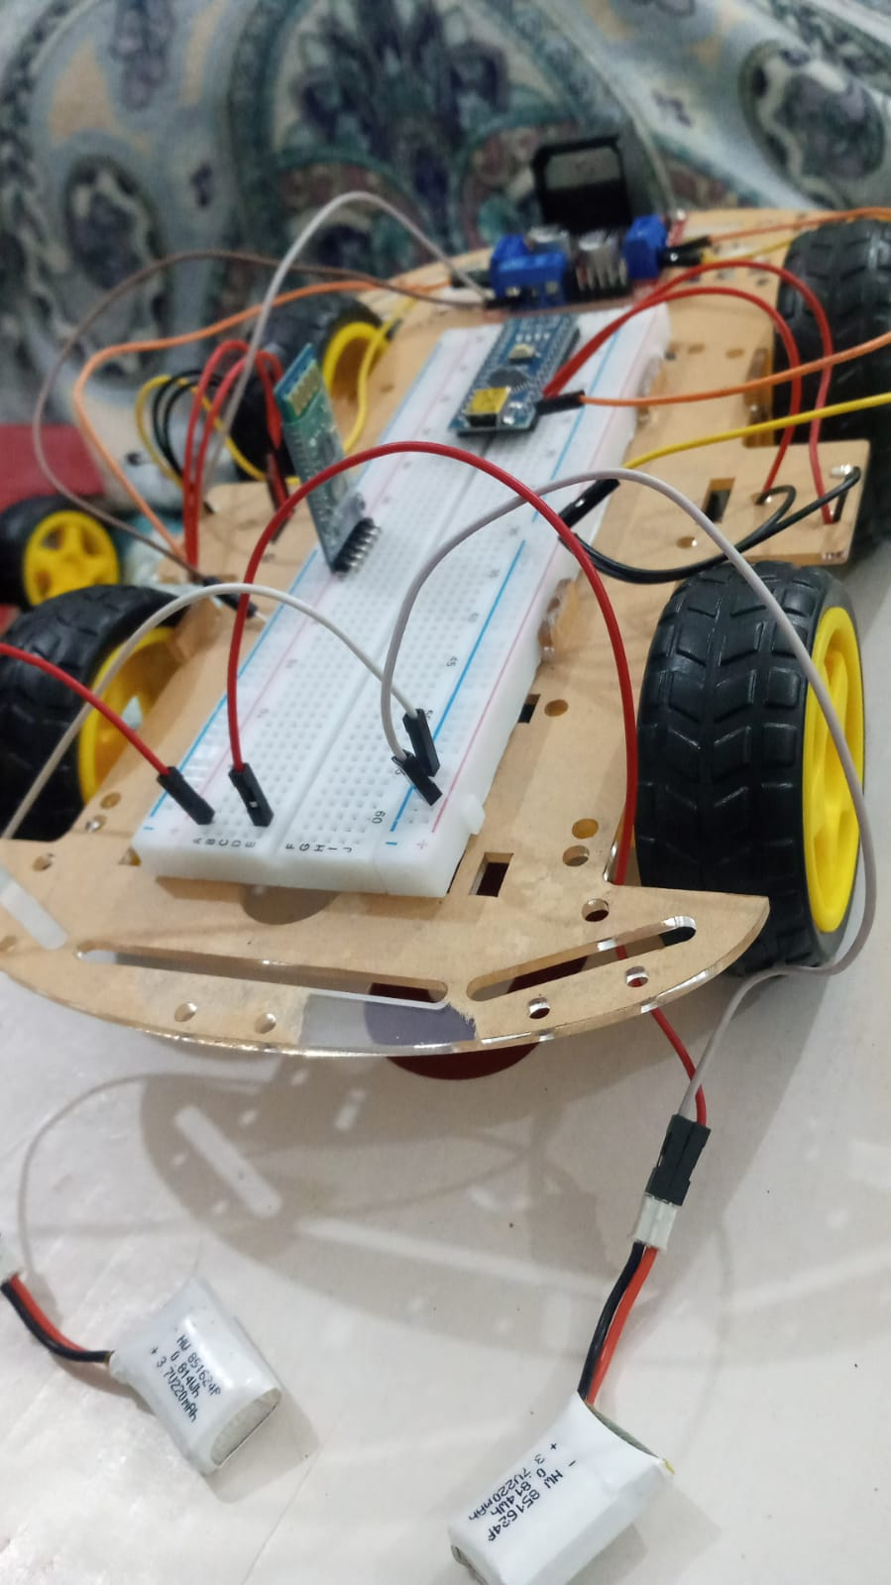

Connecting the following wires between the Arduino Nano and Bluetooth Module:

VCC – 5v || GND – GND || RXD – TX || TX – RXD

ENA – D9 || IN1 – D2 || IN2 – D3 || IN3 – D4 || IN4 – D5 || ENB – D10

Then connect the power with the Motor Driver’s GND and 5v

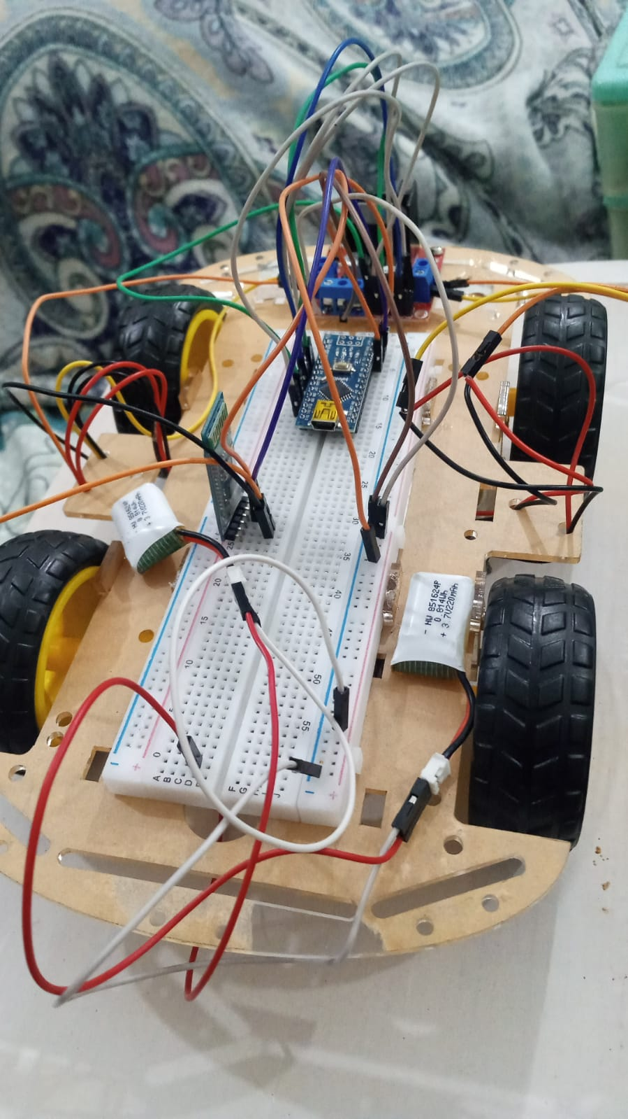

Now Remove the TX/RXD wires from the Arduino Nano and connect the Arduino with the Computer, so we can get to the programming part.

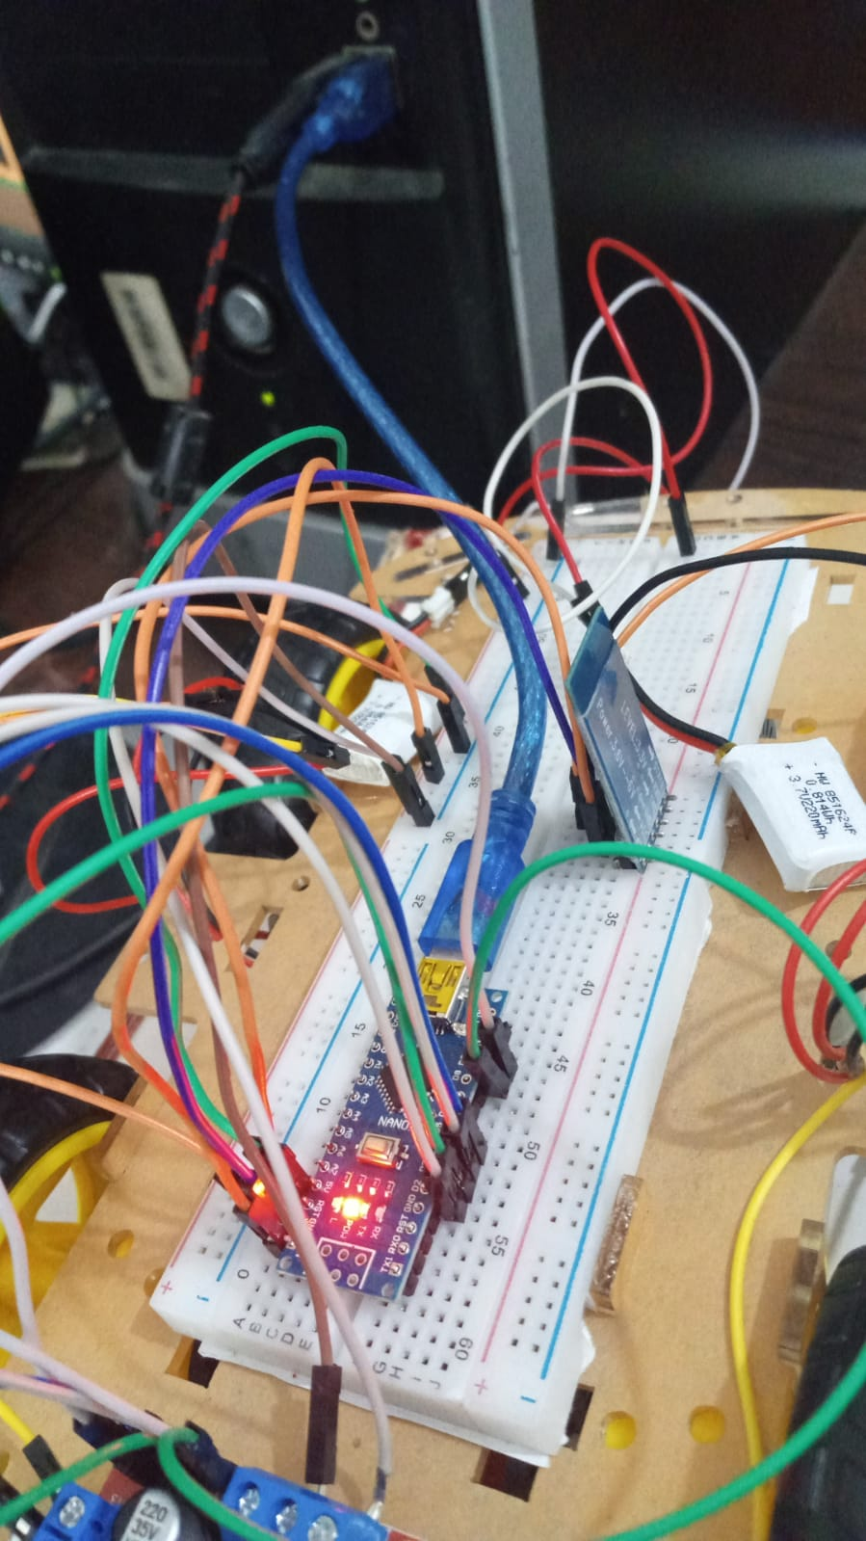

Open the IDE Software and Copy the code from the given source (provided code)

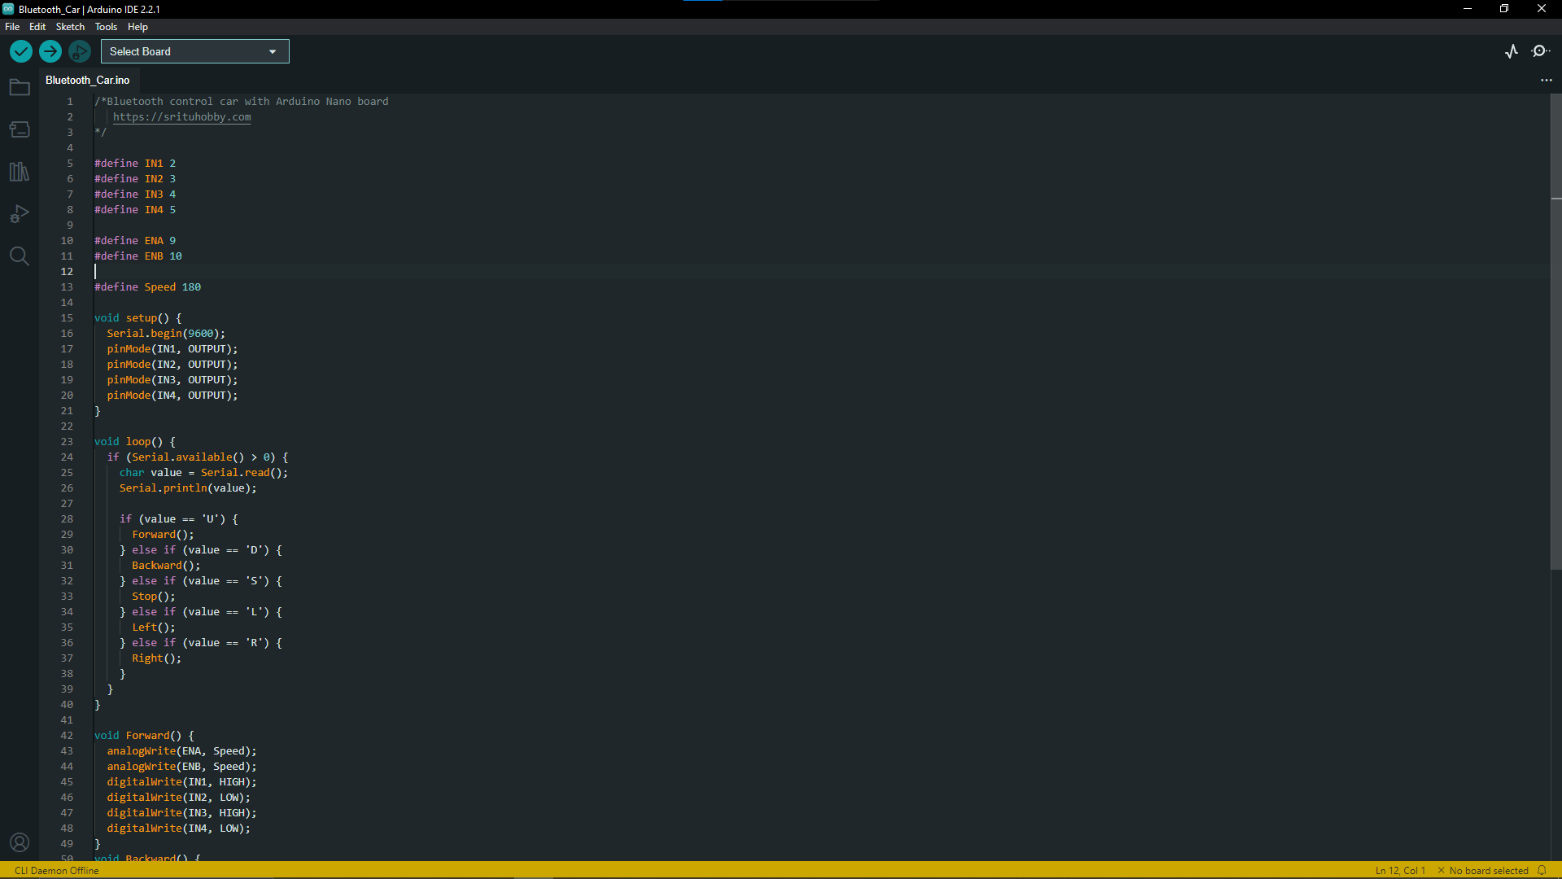

Since our device is Arduino Nano, select that Board. The Module is connected to my Computer’s PORT CMP-4, select that port.

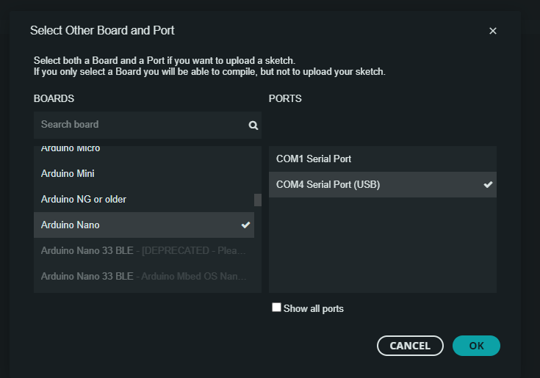

Upload the Code and then remove the USB.

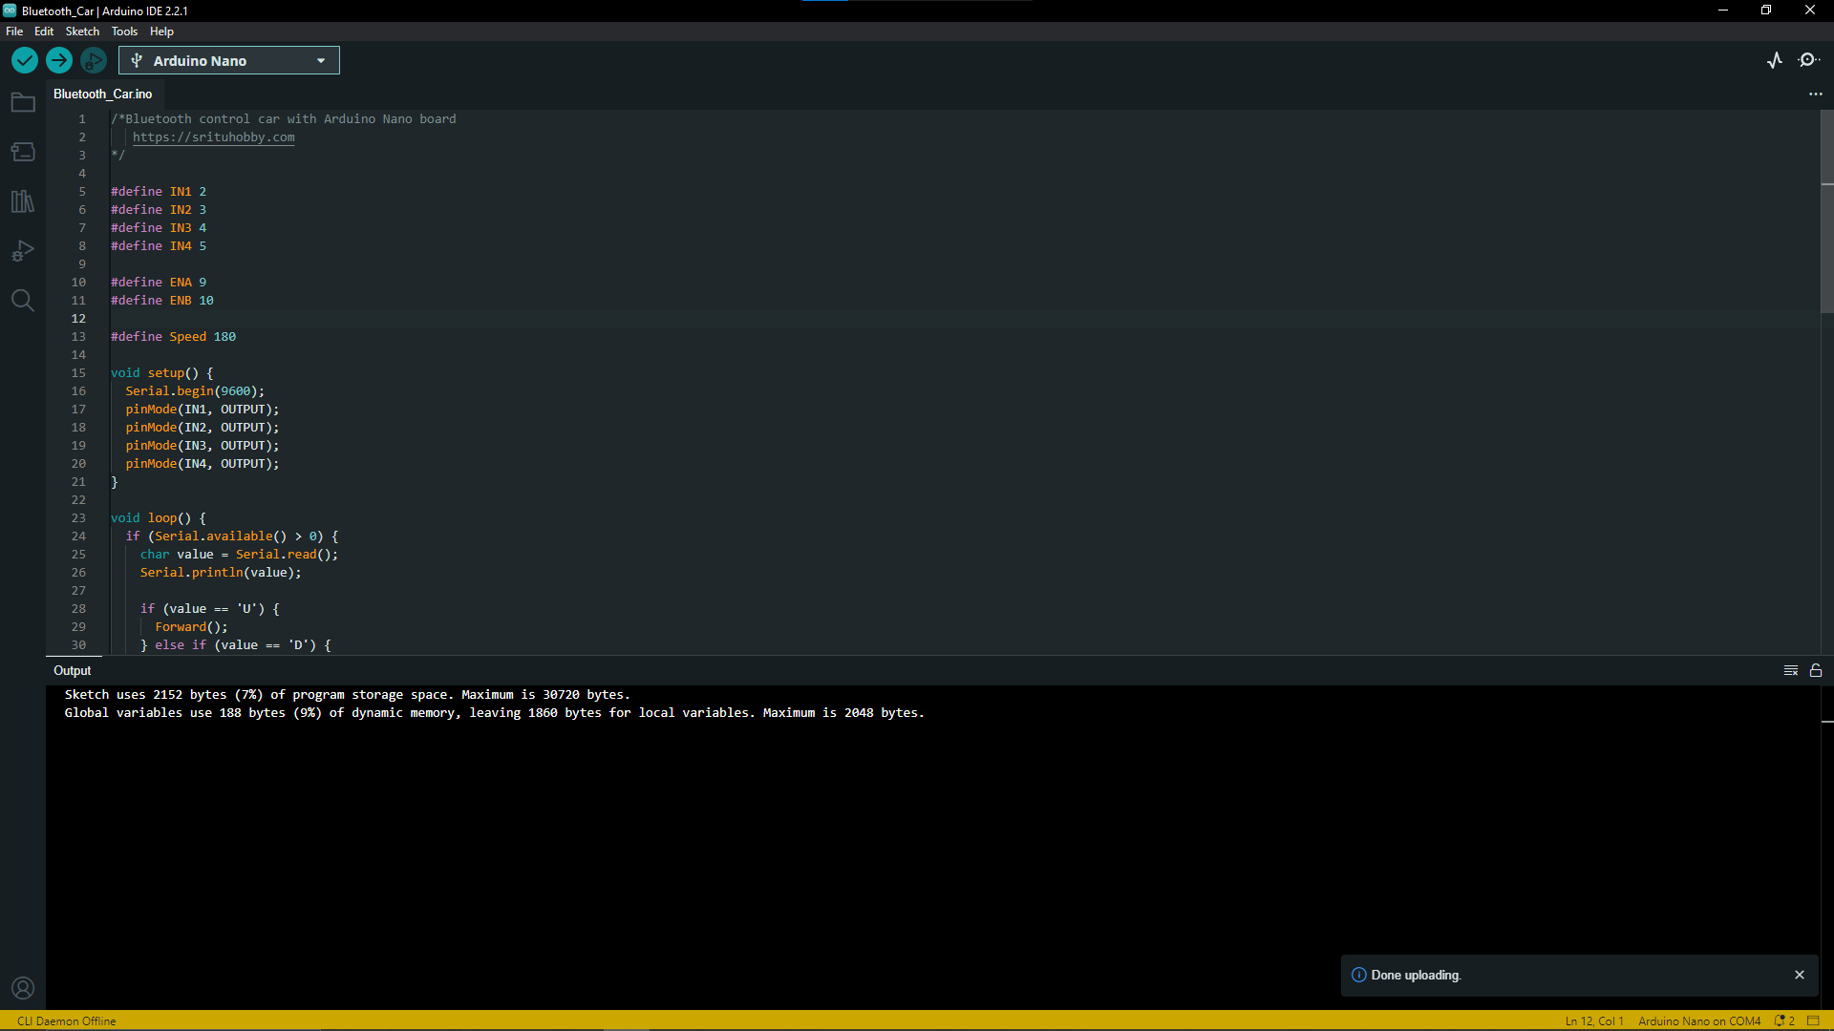

Reconnect the TX and RXD wires. Then go to your mobile and open the “SriTu Hobby” application. Then go to Control 🡪 Bluetooth Car

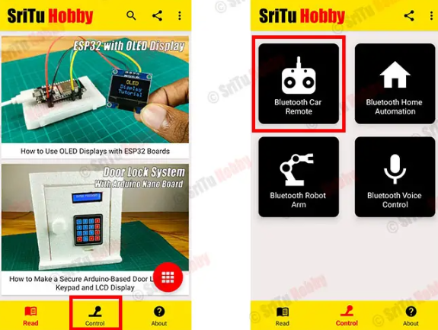

Turn your Mobile’s Bluetooth ON - then click on “Connect to Device”

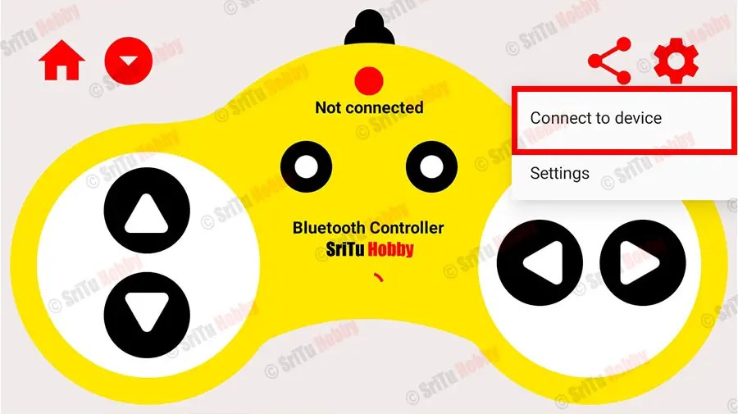

Find the ‘HC-05’ (which is our Bluetooth HC-05 module), and connect to it.

The Mobile is now successfully connected to the HC-05 Module on the Car.

Enjoy, now you have a Bluetooth controlled Remote Car! In our case, the proof of working is attached.

**Problems faced during the project:**

Initially getting the hardware was a massive problem. Mostly due to laziness, but also because we wanted to get good quality items, which can get expensive, but at the same time if we went for cheaper quality items, they might not have even worked, which can be a bigger issue than spending some more money.

Secondly, after getting everything, and putting it all together the first time, we made some rookie mistakes, of not handling the delicate things with care, thankfully nothing was damaged, but there were minor mistakes made while connecting the wires… let’s just say in short, if the battery power was high voltage, there would have been a short-circuit or a fried module. Thankfully that did not happen either, though the car did fall down from the bed a couple of times..

**References:**

* <https://srituhobby.com/how-to-build-a-bluetooth-control-car-with-arduino-nano-and-hc-05-module/>
* <https://youtu.be/sncdnRAta_8?si=KzEdPXokUnWk3WHp>